**Usability testing consent form by Harry Parker**

**If you need to contact me:**

**My Email Address is:** [hspark5@outlook.com](mailto:hspark5@outlook.com)

**Test Session**

During this test session, your activity will be recorded and used in research for developing a mobile app about booking Farm based holiday accommodation. The agreement of this is completely voluntary and you may withdraw your consent at any time with reason.

I, James Rudd agree to take part in this user study.

By signing this consent form, I fully accept:

* To not share the project to anyone in the public that is not a part of this user test study
* All of my answers will be honest.
* To allow the person who is concluding the test study to use my name and answers for research purposes

Name : James Rudd

Email Address: jamesrudd99@gmail.com

Signature: 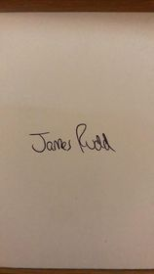

Date Signed: 17/11/2021